**Assignment 4**

|  |  |
| --- | --- |
| **Name** | Deepak Appa Rao |
| **Date** | 07 November 2022 |
| **Team ID** | PNT2022TMID12941 |
| **Title** | Signs with smart connectivity for better road safety |

**Simulation in wowki website:**

**Simulation circuit:**

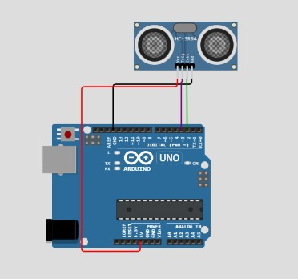

**Simulation window:**

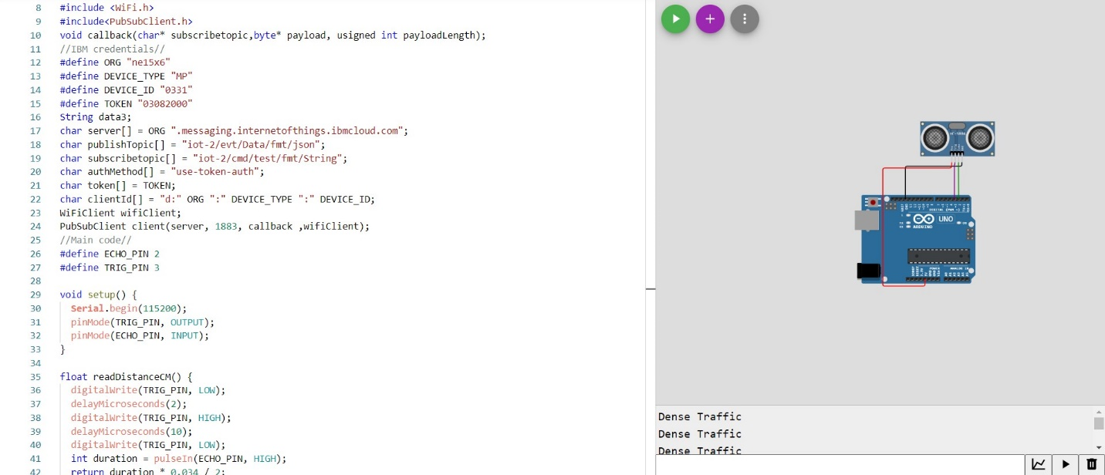

**Output at wowki simulation tool:**

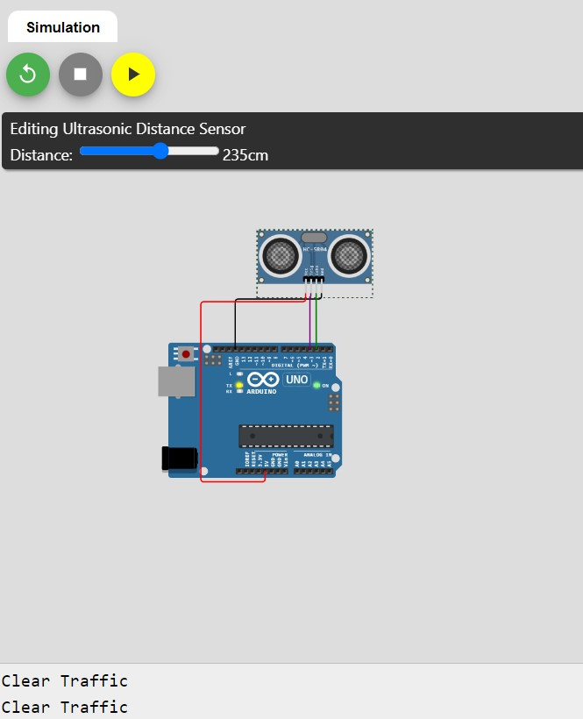 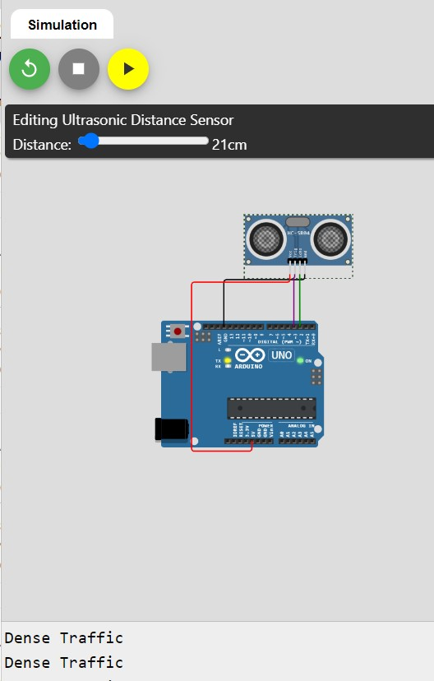

**Interfacing with IBM Watson IOT Platform:**

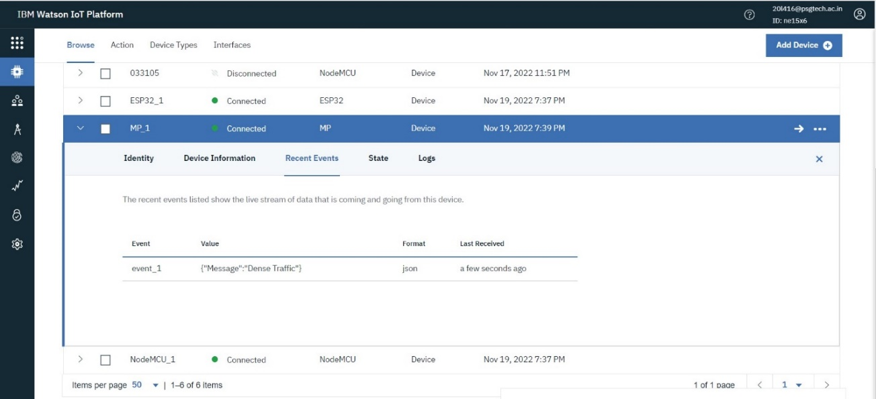

**C++ Code for wowki simulation:**

#include <WiFi.h>

#include<PubSubClient.h>

void callback(char* subscribetopic,byte* payload, usigned int payloadLength);

//IBM credentials//

#define ORG "ne15x6"

#define DEVICE_TYPE "MP"

#define DEVICE_ID "0331"

#define TOKEN "03082000"

String data3;

char server[] = ORG ".messaging.internetofthings.ibmcloud.com";

char publishTopic[] = "iot-2/evt/Data/fmt/json";

char subscribetopic[] = "iot-2/cmd/test/fmt/String";

char authMethod[] = "use-token-auth";

char token[] = TOKEN;

char clientId[] = "d:" ORG ":" DEVICE_TYPE ":" DEVICE_ID;

WiFiClient wifiClient;

PubSubClient client(server, 1883, callback ,wifiClient);

//Main code//

#define ECHO_PIN 2

#define TRIG_PIN 3

void setup() {

**Serial**.begin(115200);

  pinMode(TRIG_PIN, OUTPUT);

  pinMode(ECHO_PIN, INPUT);

}

float readDistanceCM() {

  digitalWrite(TRIG_PIN, LOW);

  delayMicroseconds(2);

  digitalWrite(TRIG_PIN, HIGH);

  delayMicroseconds(10);

  digitalWrite(TRIG_PIN, LOW);

  int duration = pulseIn(ECHO_PIN, HIGH);

  return duration * 0.034 / 2;

}

void loop()

{

  float distance = readDistanceCM();

  if(distance<25)

  {

**Serial**.println("Dense Traffic");

  }

  else

  {

**Serial**.println("Clear Traffic");

  }

  delay(100);

}